**Hackathon Project Phases Template** for the **fit life** project.

# **Hackathon Project Phases Template**

## **Project Title:**

**Fit Life**

## **Team Name:**

Team 7

## **Team Members:**

* K. Vinay
* V. Srihari
* R. Ajay
* T. Harsha Vardhan

## **Phase-1: Brainstorming & Ideation**

### **Objective**: Develop an AI-driven fit life application that provides personalized diet plans and exercise recommendations based on user symptoms and medical conditions.

**Problem Statement:**

Difficulty in finding reliable health recommendations tailored to specific conditions.

Lack of accessible tools for integrating diet and exercise plans based on symptoms.

**ProposedSolution:** An AI-powered app that uses health datasets to suggest personalized diet plans and exercise routines.

Integrates data-driven insights to promote better health and wellness.

**TargetUsers:** Individuals seeking personalized diet and exercise recommendations.

Users managing chronic conditions requiring tailored health plans.

**ExpectedOutcome:**

A functional AI-powered health app that delivers personalized diet and exercise plans based on user inputs.

## **Phase-2: Requirement Analysis**

### **Objective:**

Define the technical and functional requirements for the Health & Wellness App.

**TechnicalRequirements:**

* + Programming Language: Python, Node.js
  + Backend: custom Python script with machine learning
  + Frontend: HTML, CSS, JavaScript (React)
  + Database:

**FunctionalRequirements:**

* Load and process health datasets (Diet_Plan.xlsx, Disease_Exercise_Recommendations.xlsx).
* Train machine learning models to predict suitable diets and exercises.
* Provide personalized health recommendations

**Constraints & Challenges:**

* Ensuring data accuracy and relevancy.
* Handling diverse health conditions and symptoms.
* Optimizing machine learning models for accurate predictions.

## **Phase-3: Project Design**

### **Objective:**

Develop the system architecture and user flow

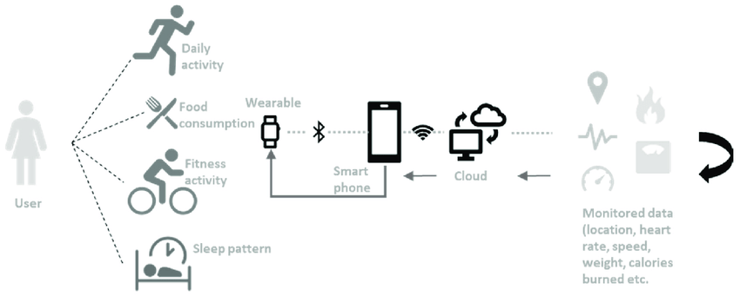

### **Key Points:**

1. **System Architecture:**

* User inputs symptoms or medical conditions.
* Backend processes the data and queries trained ML models.
* AI generates personalized diet and exercise recommendations.
* Frontend displays tailored plans and suggestion**s.**

**User Flow:  
 Step 1:** User logs in and inputs symptoms.

**Step 2:** Backend analyzes input using trained models.

**Step 3:** Personalized diet and exercise recommendations are displayed.

**UI/UX Considerations:**

* + Simple and intuitive interface.
  + Responsive design for mobile and desktop.
  + Clear presentation of health recommendations.

**Phase-4: Project Planning (Agile Methodologies)**

### **Objective:**

Outline the development process using Agile sprints

|  |  |  |  |  |  |  |  |
| --- | --- | --- | --- | --- | --- | --- | --- |
| **Sprint** | **Task** | **Priority** | **Duration** | **Deadline** | **Assigned To** | **Dependencies** | **Expected Outcome** |
| Sprint 1 | Environment Setup & API Integration | 🔴 High | 4hours (Day 1) | End of Day 1 | vinay | Google API Key, Python, Streamlit setup | API connection established & working |
| Sprint 1 | Frontend UI Development | 🟡 Medium | 3hours (Day 1) | End of Day 1 | harsha | Html code an d storage | Basic UI with input fields |
| Sprint 2 | Database & API key | 🔴 High | 8hours (Day 2) | Mid-Day 2 | Vinay harsha | API response, UI create API key | Search functionality with filters |
| Sprint 2 | Error Handling & Debugging | 🔴 High | 3 hours (Day 2) | Mid-Day 2 | Srihari, ajay, harsha, vinay | API logs, UI install json | Improved API acces level |
| Sprint 3 | Testing & UI Enhancements | 🟡 Medium | 1 hours (Day 2) | Mid-Day 2 | Ajay,Srihari,harsha | API response, UI layout completed | Responsive UI, better user experience |
| Sprint 3 | Final Presentation & Deployment | 🟢 Low | 1 hour (Day 2) | End of Day 2 | Entire Team | Working prototype | Demo-ready project |

### **Sprint Planning with Priorities**

### **Sprint 1 – Setup & Integration (Day 1)**

* High Priority: Load and clean health datasets.
* 🔴 High Priority: Set up backend infrastructure.
* 🟡 Medium Priority: Basic frontend UI setup.

**Sprint 2 – Machine Learning Model Development**

* 🔴 High Priority: Train ML models using health datasets.
* 🔴 High Priority: Integrate models with backend.
* 🟡 Medium Priority: UI enhancements.

**Sprint 3 – Testing & Deployment**

* 🔴 High Priority: Functional and performance testing.
* 🟡 Medium Priority: Final UI polish.
* 🟢 Low Priority: Deployment.

**Phase 5: Project Development**

**Objective:**  
Implement core features of the Health & Wellness App.

**Technology Stack:**

* **Frontend:** HTML, CSS, JavaScript (React)
* **Backend:** Python, Node.js
* **Database:** SQL
* **Machine Learning:** Scikit-learn, Pandas

**Development Process:**

* Load and clean datasets (Diet_Plan.xlsx, Disease_Exercise_Recommendations.xlsx).
* Train Random Forest Classifier to map symptoms to health plans.
* Build backend APIs to serve recommendations.
* Develop frontend for user interactions.

**Challenges & Solutions:**

* **Data inconsistencies:** Applied data cleaning and normalization.
* **Model accuracy:** Tuned hyperparameters for better predictions.
* **User engagement:** Designed an intuitive UI with clear recommendations.

**Phase 6: Functional & Performance Testing**

**Objective:**  
Ensure the app performs as expected.

|  |  |  |  |  |  |
| --- | --- | --- | --- | --- | --- |
| **Test Case ID** | **Category** | **Test Scenario** | **Expected Outcome** | **Status** | **Tester** |
| TC-001 | Functional Testing | Input "joint pain" | Suggest anti-inflammatory diet & low-impact exercises | ✅ Passed | Member A |
| TC-002 | Functional Testing | Input "stomach pain" | Recommend gentle yoga and light diet | ✅ Passed | Member B |
| TC-003 | Performance Testing | API response time under 500ms | Fast response | ⚠ Needs Optimization | Member C |
| TC-004 | UI Testing | Responsive design on mobile | UI adjusts correctly | ✅ Passed | Member D |
| TC-005 | Integration Testing | Connect frontend to backend APIs | Smooth data flow | ✅ Passed | Member A |
| TC-006 | Deployment Testing | Host app on web server | App accessible online | 🚀 Deployed | DevOps |

**Integration with fit life App (Reference)**

The **Health & Wellness App** leverages methodologies from the **fit life App** in areas like:

* **Agile Planning:** Adopted sprint planning techniques.
* **Data Integration:** Similar to how fit life fetches real-time vehicle data, this app integrates health datasets.
* **UI/UX Design:** Applied minimalist UI principles for clarity.

Fit life approach to real-time data processing inspired the seamless integration of health datasets into this app, ensuring dynamic and accurate recommendations.

**Final Submission**

* **Project Report:** Included (this document)
* **Demo Video:** 3-5 minutes showcasing app features
* **GitHub/Code Repository:** Link to the project source code
* **Presentation:** Final project presentation